This Vision Card outlines the desired business outcome, context, problem and vision for your new project idea. The following questions will guide technical teams in providing ball-park T Shirt sizing for the proposal. If unsure, provide your best first draft — your Business Engagement Mobilisation Partner will help you refine this after submission.

Desired SMART Business Outcome
Business outcomes should be measurable change in a business metric, within a set timescale, for a clear stakeholder, and aligned to one or more strategic goals e.g.
- Reduce sales cycle duration for B2B customers by 20% within 12 months, enabling faster revenue realisation and improved customer experience
- Increase ‘fix broadband fault in one contact’ rates from 55% to 85% by Q4 2027, reducing operational cost-to-serve and increasing customer satisfaction in our network
Proposed Title | Data extract for Telephony customer identification -ID304
What type of state change/improvement must the project deliver? | Reducing agent call handling times which in turn reduces Opex cost with Accenture and Capita
In which business metric? | Customer onboarding time and customer NPS
For which specific stakeholder or business user? (Primary outcome beneficiary) | Operations
By how much? (Quantified amount or percentage is required) | £150,000 operational efficiency saving per month, once teams are migrated onto the new platform
What is the current value for this business metric? | £4m savings
Within what timeframe? | Over 4 years
What strategic outcome does this support? | Driving operational efficiency savings

Stakeholders
Proposer | Sally Ockwell, O2 Daisy CTIO
Sponsor (accountable for the business outcome) | Jo Watts and Nicholas Collines
Finance Business Partner | Patricia Harding
Other stakeholders (Optional)
Only include if consulted to date. e.g., Legal, Regulatory, Insights, Care, Retail Ops.
Role | Name
Transformation Lead | Ian Scott, Head of Business Transformation
Architecture Lead | Andy Bowyer, Director of Architecture & Innovation
Contact Centre/Care Lead | Victoria Dean

Tracking information
What ID does your business unit or demand forum use to track this proposal? | ID304
What is the unique budget reference for the budget that is likely to fund this item? | Not known
Which business division will be funding this proposal? | B2B O2 Daisy
Which demand forum or person within your business unit has prioritised this item as a candidate for investment? | O2 Daisy SteerCo.  Jo Watts & Paul Edwards
When was the priority of this idea approved as a candidate for investment? | 10/02/26
If known, when is this planned to attend Investment Committee? | 10/02/26
List any known dependencies (if applicable) Leave blank if unknown
Is this an NDA’d project? If so, who is the NDA contact? | N/A
For admin use only
Date received by Business Engagement and Mobilisation (BEM) team
Vision has been reviewed with key architects / ESA domain owners? | Y/N
Date approved for platform assessment by BEM | DD/MM/YY

Who is impacted and what is broken today?
Who is the prime beneficiary of this change?  Define the specific customer segments, colleague groups, or business units impacted | O2 Daisy.  All care and sales agents across multiple tech stacks will be amalgamated onto one telephony solution, with automated call summarization and pre call connection AI bot ID&V customer check and auto call summarization.
Which products or services are in scope? | N/A
Which channels, processes or (if known) systems are in scope?  Specify the channels, processes or systems involved today | Voice, Chat and payments call flows plus Outbound Dialler on Amazon Connect.  Workforce Management (scheduling, quality management, call recordings) on Verint.  Post call customer surveys will be conducted by Genesys and not Amazon Connect.  PCI card payments on Amazon Connect using Sequence Shift will be replaced by capability on Genesys.  The Amazon Connect web chat solution will be replaced and the Website widget on VMB website updating.
What is happening today?  Describe the current experience and known impacts (1–3 sentences) | O2 Daisy has teams spread across 4 telephony solutions.  Calls are routed to 4 different telephony stacks for O2Daisy,  All sales, service and sales agents across O2 Daisy will be migrated onto Genesys over 2026.  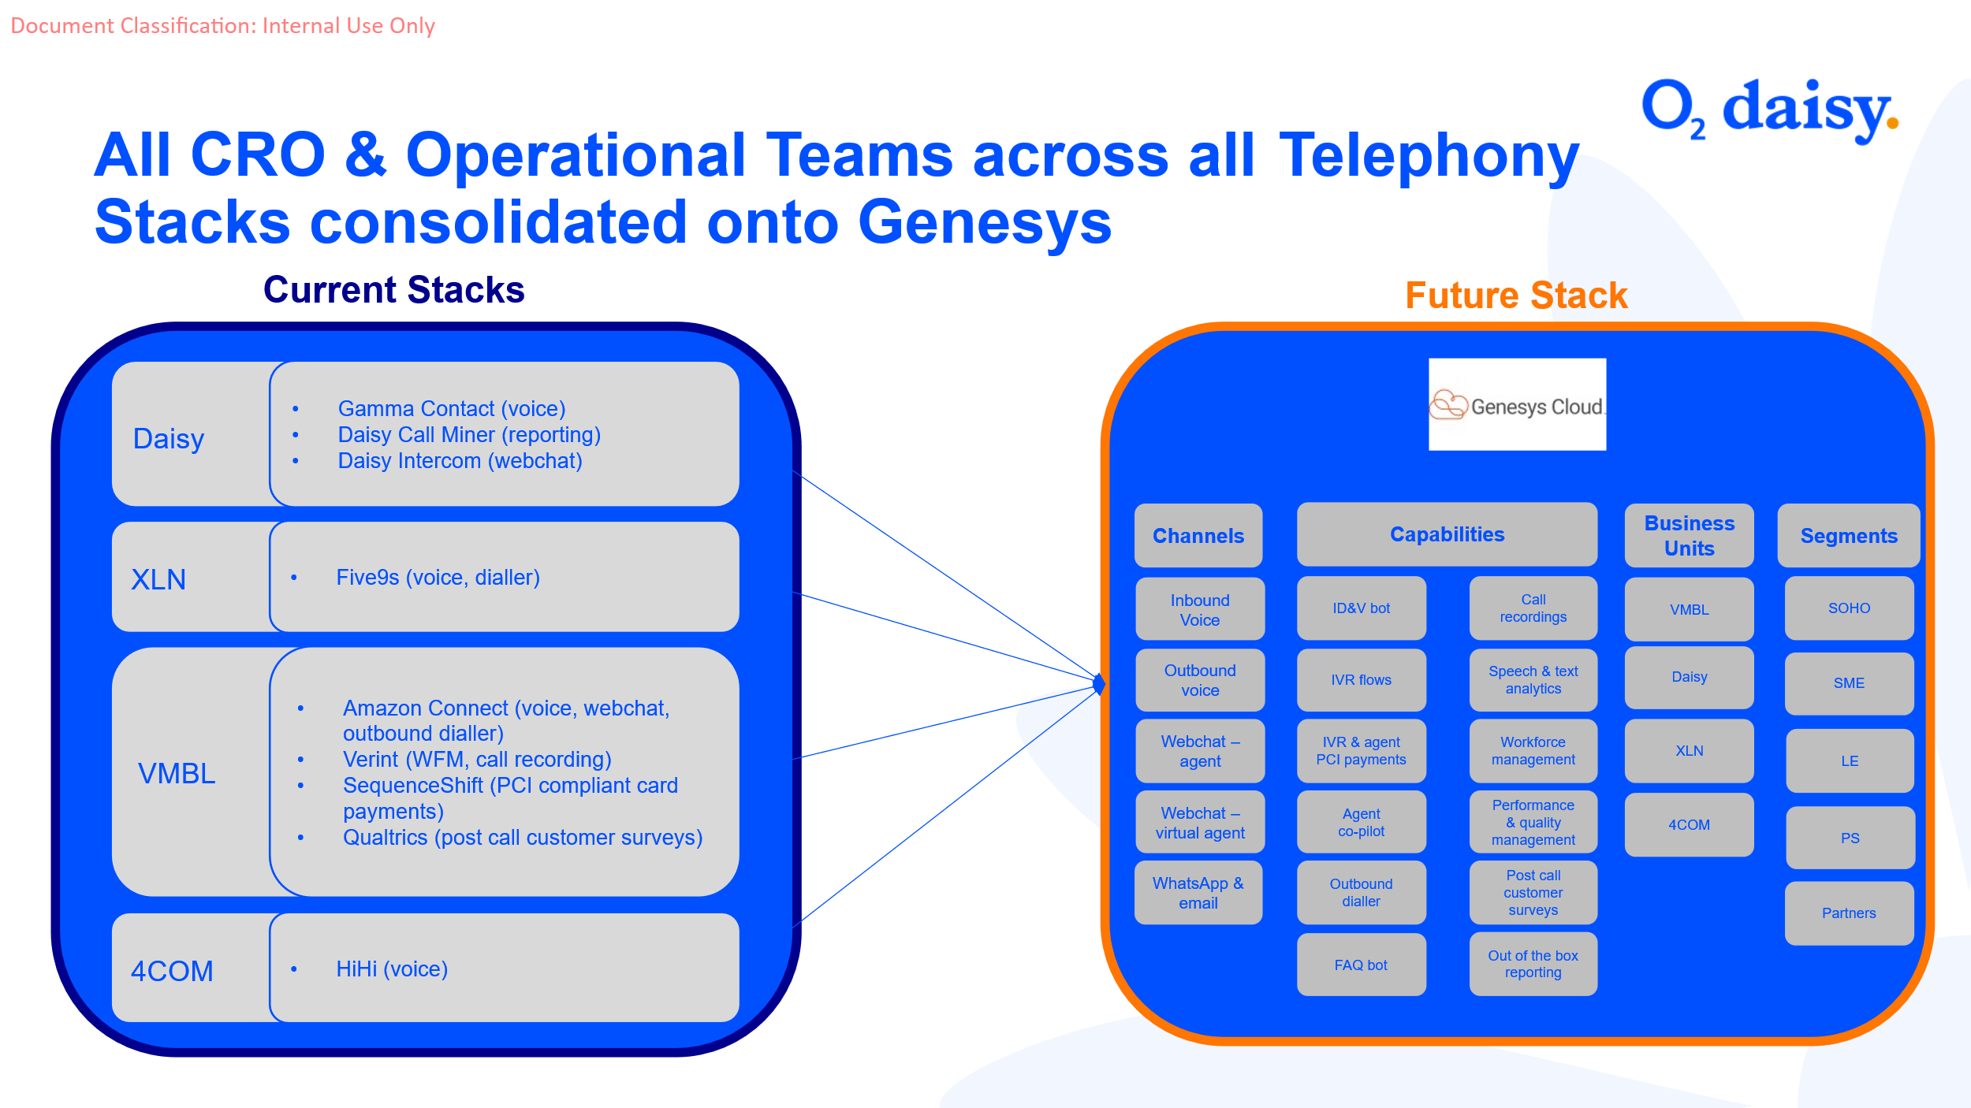
What is the problem or opportunity?  Explain why the current state is undesirable, and what needs to change (1–3 sentences) | O2 Daisy wishes to migrate off AmazonConnect and get all agents onto on to a new tech stack, Genesys Cloud.  This demand is to aid the AI bot ID&V check prior to delivering the calls to agents. In order to do this, O2 Daisy requires a daily data feed/file from VMO2 GCP data lake or from the native system if it is not in GCP. It is believe that the data required originates from the following systems.  DISE  Red Salesforce  Purple Salesforce  ICOMs  Comet  NRM  Remedy  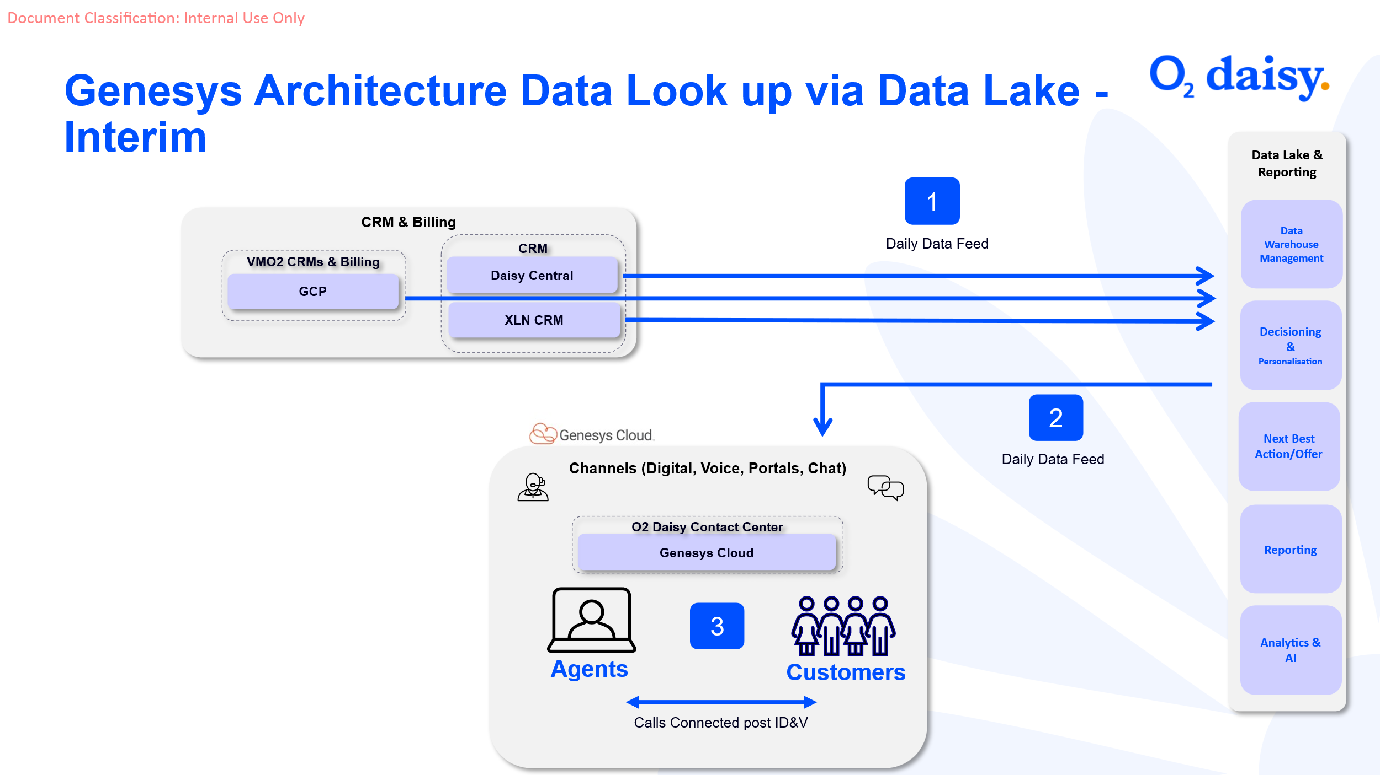

What must change?
What is your future vision? | We would require a daily feed of data with the following data points, as one file either from the systems or from GCP  Purpose & priority Data Point Name Customer Cohort  VMBL SO Mobile VMBL SO Fixed VMBL SME Mobile VMBL SME Fixed VMBL - LEPS Mobile VMBL - LEPS Fixed  DPA (1) CLI GCP (DISE) GCP (ICOMS) GCP (DISE) GCP (ICOMS, NRM) GCP (DISE) GCP (ICOMS, NRM)  DPA Billing Account Number GCP (DISE) GCP (ICOMS) GCP (DISE) GCP (ICOMS, NRM) GCP (DISE) GCP (ICOMS, NRM)  DPA PIN N/A N/A GCP (DISE) GCP (ICOMS, NRM) GCP (DISE) GCP (ICOMS, NRM)  DPA DPA password N/A N/A N/A N/A N/A N/A  DPA Company name GCP (DISE) GCP (Red Salesforce) GCP (NG Salesforce) GCP (NG Salesforce) GCP (NG Salesforce) GCP (NG Salesforce)  DPA Address GCP (DISE) GCP (Red Salesforce) GCP (NG Salesforce) GCP (NG Salesforce) GCP (NG Salesforce) GCP (NG Salesforce)  DPA Post code GCP (DISE) GCP (Red Salesforce) GCP (NG Salesforce) GCP (NG Salesforce) GCP (NG Salesforce) GCP (NG Salesforce)  DPA Last Four Digits of Banking GCP (DISE) GCP (ICOMS) GCP (DISE) GCP (ICOMS, NRM) GCP (DISE) GCP (ICOMS, NRM)  DPA Segment - SOHO/SME/LE/PS GCP (DISE) GCP (Red Salesforce) GCP (NG Salesforce) GCP (NG Salesforce) GCP (NG Salesforce) GCP (NG Salesforce)  DPA Product - VMB Broadband, GCP (DISE) GCP (ICOMS) GCP (DISE) GCP (ICOMS, NRM) GCP (DISE) GCP (ICOMS, NRM)  O2 Broadband, MIA, DIA,  O2 Mobile, MS365, MDM, UC  Routing (2) Overdue invoice  Routing Open order  Routing Collection event  Routing Delivery event vs connected  Routing Complaint  Routing Fraud  Routing Case Reference  Routing Order ID
How does this differ from the current state? | We will migrate users from Amazon Connect to Genesys over a 6 month period
What will success look like for your primary beneficiary | O2 Daisy receives a daily file to ingest and send to Genesys so that calls are successfully delivered to agents after the ID&V check has been performed by the AI bot
Are there any journeys, workflow, or screen mockups that illustrate or support this requirement? | 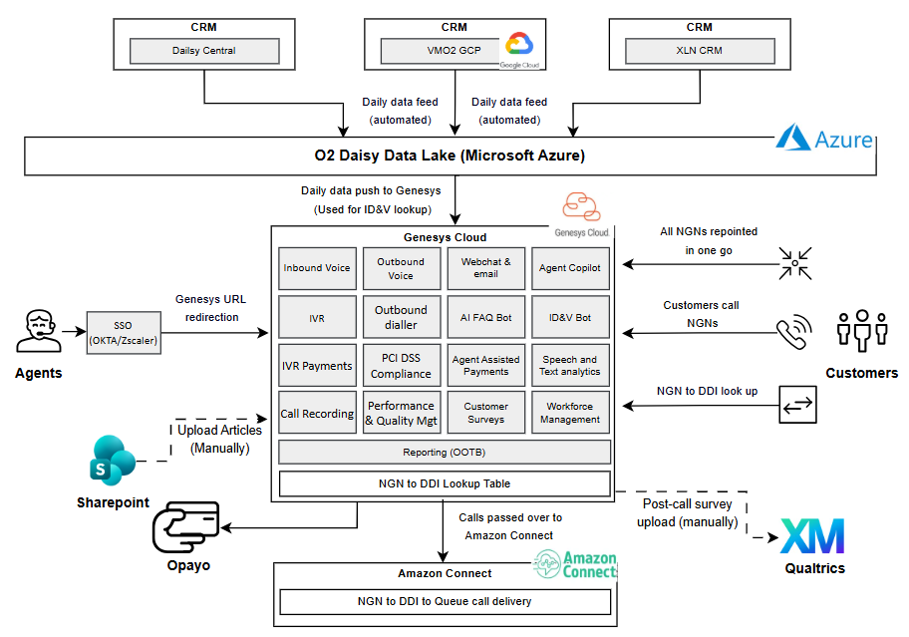
What constraints or non-negotiables must the future solution respect? | We require this data for all segments of customers.  The feed needs to be daily or maximum, every 2 days
Is there anything explicitly out of scope? | A separate data file per system.
When do you want this to go live? | Commercial launch in June 2026.  Testing end May.
Why must it happen then? e.g. Critical drivers for timing. | To realise the benefits outlined in the business case so we can migrate teams
Does this have a value case yet? e.g. Have you assessed where and how much the value will be derived from this change? | Yes but it is an O2 Daisy case
What is the approximate revenue uplift / cost saving from this? | Operational savings of around £150k per month

- High level Requirements
High level requirements describe what the change needs to deliver — not how it should be built. Use short, simple statements focused on capabilities, rules, or behaviors the future solution must support.
Guidance:
- Clear high‑level requirements help ensure faster and more accurate sizing
- List the essential capabilities or features needed to achieve your desired outcome (e.g., “Customers must be able to…”, “The system must allow…”)
- Focus on requirements, not solutions (avoid naming specific technologies or designs)
- Include any critical business rules, data needs, reporting requirements, or compliance considerations
- For customer impacting proposals you may wish to consider the specific elements of the customer lifecycle that each requirement impacts e.g. find/explore, buy/upgrade, pay/bill, getting started/use, manage, get help, stay/leave.
- *MVP = These requirements must be delivered by the project to achieve the minimum viable customer or commercial outcome
# | Change / Requirement |  | MVP*
1 | O2 Daisy must receive a consolidated daily data file, covering all customer segments from GCP or the native system, in a merged file, delivered securely to the O2 Daisy landing zone |  | Y
2 | The DPA data points provided earlier in the document are critical for Day 1 and are priority 1. |  | Y
3 | The routing data points are priority 2 |  | Y
4 |  |  | Y
5 |  |  | Y
6 |  |  | N
7
8
9
10
What are your reporting or self-serve analytics (data democ.) requirements? |  | N/A | Y

5.1 Non-Functional Requirements (NFR)
A non-functional requirement explains the standards the solution must meet — such as speed, reliability, security, or ease of use — so that the experience works well for customers and colleagues, not just functionally.
Do you know how many customers or transactions there will be?  Delete as appropriate | Medium (10–100k monthly)
Response times or availability | Scheduled time for the file to drop daily so an automated process can be defined to upload to Genesys
Are there any security or privacy requirements?  If unsure, select ‘unknown’ | The file transfer must be secure
Any legal or regulatory compliance requirements? | O2 Daisy are addressing any DPO concerns
Are there any Fraud requirements? | No
Accessibility / vulnerable customer requirements | The journey must support vulnerable customers

  - What parts of the business are likely to be impacted?
Have you thought about how your requirement will impact key channels or operational units in VMO2? Say if you believe an operational department will be impacted by implementing this idea.
Operational area | Impact? | How
CTO: Will this requirement involve changes to the mobile or fixed network or the services they deliver? e.g. connectivity, coverage, messaging, etc. | ?
Will CIO or CTO operational teams need to change the way they support our services? | Y
Digital channels or App | Y
Commercial and Product teams | Y
Marketing and Sales
Shop and Basket | Y
Retail stores | Y
Care and Retentions | Y
Billing, Payments, Customer Finance, Insurance
Logistics, supply chain and field operations | Y
Other: (State)

Supporting Information
Has any solution assessment been done? Include links to existing solution options, blueprints, etc. that may support T Shirt sizing | Insert link here.
Are there any other supporting documents or references  e.g. Links to slides, customer personas etc | Insert link here.

For information: Next steps
- Pre-submission checks: An early conversation with your Business Engagement and Mobilisation (BEM) Partner is advisable. They may suggest a simpler delivery route. They may also be able to support early shaping of your vision around technical capabilities.
- Submission: Once you have a potential sponsor, budget reference and priority from the person or body that prioritises demand in your division, please submit your draft Vision Card to the BEM team [Insert BEM team inbox here]
- Vision card review: A Business Engagement and Mobilisation Partner will engage with you to refine and clarify important details in your vision required to obtain the best early impact assessment. The BEM partner may drive conversations with key architects to ensure we obtain the most cost-effective recommendation ahead of sizing.
- T-Shirt Sizing: When judged fit for purpose, the Vision card will be submitted for platform assessment. This will lead to an initial T-shirt-sizing, and clear ownership of delivery between TCS and TechM.
- Mobilisation: Further mobilisation tasks will depend on funding status, whether the idea is in the baseline plan, and future changes to the delivery quotation process that are TBC with the new delivery suppliers.

